Focus Group for App Design

|  |  |  |  |
| --- | --- | --- | --- |
|  | App Design1 (Marvel) | App Design 2 ( | App Design 3 |
| Overall Design | 7 | 9 | 9 |
| User Experience | 8.5 | 9 | 9 |
| Ease of use | 9 | 8.5 | 9 |
| Usefulness | 7.5 | 9 | 9 |

App 1

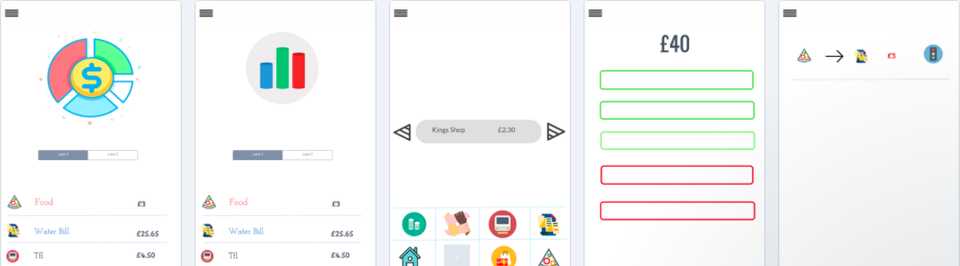

App 2

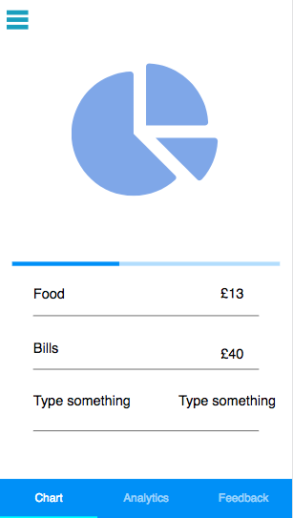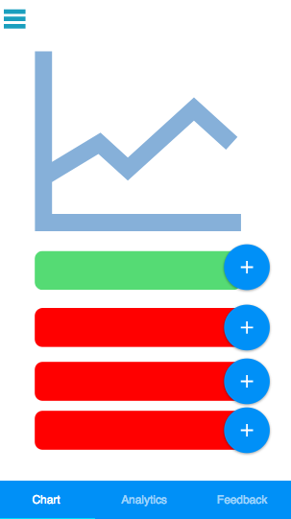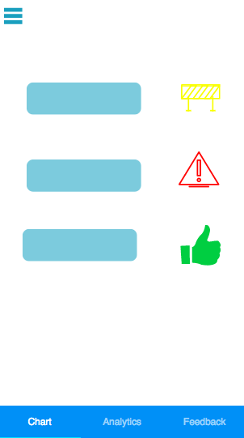

App 3

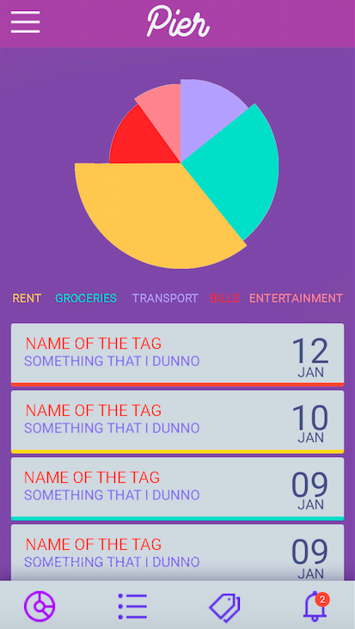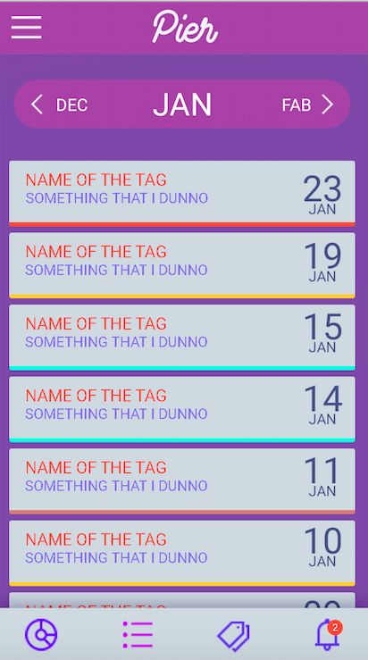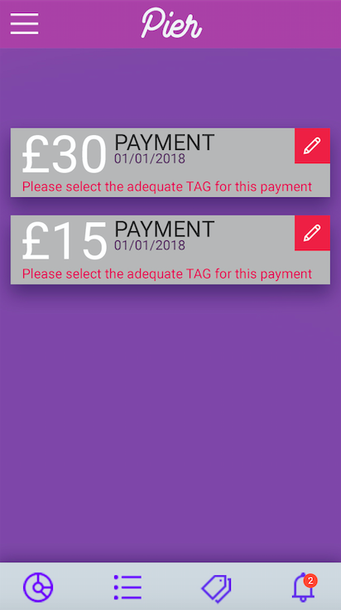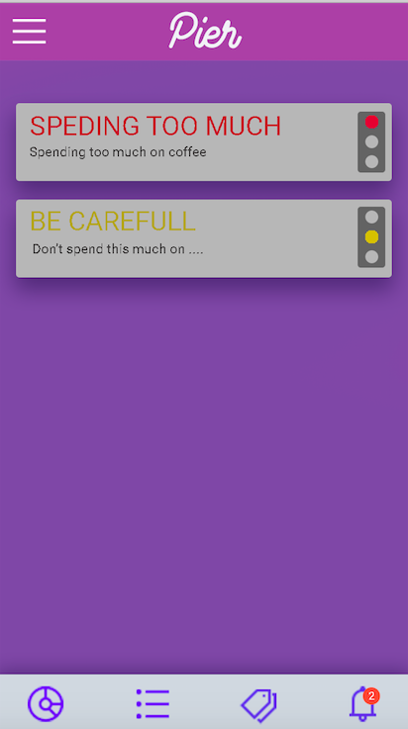

**Breakdown –**

Which App has the best breakdown?

App3

What would you change/add to make it better in your opinion?

Another colour for the spending, grey is bad

**Data Analytics -**

Which App has the best Data Analytics ?

App2

What would you change/add to make it better in your opinion?

We Like the diagram

**Tags-**

Which App has the best Tags?

App2

What would you change/add to make it better in your opinion?

We like the convenience

**Alerts**

Which App has the best Alerts?

App2

What would you change/add to make it better in your opinion?

Much clearer. Not too much going on, especially on non tech users

**Input Method**

Method 1 – Leave to side bar- in terms safety – overall choice

Method 2 – Put in tab -

More convenient

**Any other comments/ Suggestions**

Sound app